A “Scope, Simulation and Story” approach to identify future spatial development scenarios

Orlando Roman[1]1, Jan Kwakkel[2]2, Bryan Adey[3]1 and Benjamin Black[4]1

1Department of Civil, Environmental and Geomatic Engineering. ETH Zürich

2Faculty of Technology Policy and Management. TU Delft

CUPUM 2025

**Summary**

This study shows introduces a “Scope, Simulation and Story” approach, instead of the classical “Story and Simulation”. Our approach, has potential to enhance scenario planning by integrating participatory processes, spatial development simulation models and spatial analysis to define scenario boundaries that reflect spatial patterns. We apply this method to simulate spatial development in the Canton of Zurich for 2050 using a cellular automata Land Use Cover Change (LUCC) model. By varying LUCC transition rates and the influence of different LUCC drivers, we simulated an ensemble of 800 potential futures and identified four distinct scenarios.

**KEYWORDS:** Scenario Planning, Spatial Clustering. Cellular Automata, Model-based Planning Support, Decision-Making under Deep Uncertainty

# Introduction

Scenario planning is a growing alternative to traditional planning approaches in recognition of the uncertain and complex interactions between the built and the natural environment. Scenario planning develops alternative stories about the future, as combinations of important drivers of change (Avin and Goodspeed, 2020; Abou Jaoude, Mumm and Carlow, 2022). Typically, scenarios are developed qualitatively, and only then some quantitative simulation models are used to assess their implications (Avin and Goodspeed, 2020; Haga *et al.*, 2023). This approach is usually known as “Scenario Storylines and Quantification” (Nakicenovic and Swart, 2000) or “Story and Simulation” (Alcamo, 2008).

Some challenges when using this approach have been highlighted in the policy analysis literature (Bankes, 1993; Lempert, Popper and Bankes, 2003; Reed *et al.*, 2022). Figure 1 schematises these main challenges through a 2x2 scenario matrix diagram, where four scenarios are proposed as the four combinations of “low” and “high” values of the two drivers, X and Y, assigned in each axis. The first challenge is to identify the main drivers (X and Y), which is usually done qualitatively through expert elicitation or participatory processes. This is difficult to do intuitively given the high number of drivers of urban development (e.g. economic, environmental, social and technological factors). Second, scenarios should be determined based on the relevance of their implications (i.e. planning outcomes or goals). When using a predefined subdivision of drivers (e.g. combinations of high and low) it is difficult to ensure that the implications of the scenarios are relevant and different between them. It is also difficult to define a more sensible boundary between scenarios instead of the categorical “low” and “high”. Third, the said predefined subdivision of scenarios risks missing out some subsets of the scenario space that do not fit one of the quadrants perfectly. All the above-mentioned challenges are especially difficult when the scenarios are spatially explicit, such as in the case of urban development scenarios.

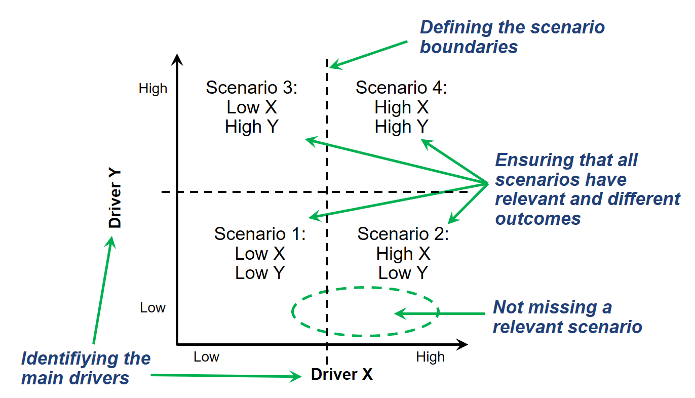

**Figure 1** Challenges of qualitative scenario development.

To tackle such challenges, exploratory modelling uses large ensembles of simulations to explore the implications of future scenarios (Bankes, 1993; Lempert, Popper and Bankes, 2003; Bryant and Lempert, 2010). In this approach, analytical procedures are applied to the ensemble of simulations to quantify the influence of multiple drivers and identify relevant scenarios. This paper introduces a “Scope, Simulation and Story” approach, which starts with a participatory scoping stage to then leverage simulations and quantitative techniques for the posterior development of scenario narratives.

# Methodology

## Scope

The first step of our approach is the formulation of the scenario planning exercise which includes the definition of the spatial and temporal constraints, the planning goals and the future uncertainties (Lempert, Popper and Bankes, 2003). Participatory processes with stakehoders are well suited for such a scoping processes.

For this paper, the scenario planning exercise consists of the identification of spatially explicit urban development scenarios for the Canton of Zurich, Switzerland by 2050. We look specifically at how different land use dynamics can create different spatially explicit scenarios.

## LUCC Model

To simulate potential future urban development in the Canton of Zurich, we used a cellular automata Land Use and Cover Change (LUCC) model through the environmental modelling software Dinamica EGO, Version 7. Different LUCC drivers were selected to evaluate their influence on the land use transitions based on previous LUCC modelling studies in Switzerland and calibrated with the LUCC occurred in the Canton of Zurich between 2009-2018. We used spatial data of the following drivers: elevation, slope, lakes, train stations, highway access points, metropolitan areas (Zurich and Winterthur) and other urban centres. The estimation of each drivers’ respective influence on the land use transitions was carried out using the Bayesian Weights of Evidence (WoE) method including in Dinamica EGO. These WoEs are then used to estimate probability maps for each transition.

## Exploratory Modelling

For the exploratory modelling, 7 factors related to the quantity of LUCC (i.e. transition rates) and two factors related to the spatial distribution of LUCC (i.e. weights of evidence) were selected, as shown in Table 1. The uncertain factors on the weights were modelled to signal a type of urban development. For example when the weight of train stations was increased, the weight of highway access points was decreased, signalling a “transport oriented development” trajectory. On the opposite direction, a “highway oriented development was created. The same strategy was applied to the weights of smaller cities/metropolitan areas and therefore “centralised” and “polycentric” urban development trajectories were developed.

We produced an ensemble of 800 future scenarios by sampling within the minimum and maximum values of the variables shown in Table 1 using the Latin hypercube sampling method.

**Table 1** CUPUM Conferences

|  |  |  |  |  |
| --- | --- | --- | --- | --- |
| Type | Uncertainties | Min. Value | Max. Value | PDF |
| Transition Rate | Residential low-density to high-density | 0.25 | 0.35 | Uniform |
| Transition Rate | Residential high- to low-density | 0.14 | 0.24 | Uniform |
| Transition Rate | Industrial/commercial to residential low-density | 0.04 | 0.05 | Uniform |
| Transition Rate | Industrial/commercial to residential high-density | 0.10 | 0.12 | Uniform |
| Transition Rate | Agricultural to residential low-density | 0.04 | 0.07 | Uniform |
| Transition Rate | Agricultural area to residential high-density | 0.04 | 0.05 | Uniform |
| Transition Rate | Agricultural area to industrial/commercial | 0.04 | 0.06 | Uniform |
| Weights of Evidence | Train Stations/Highway access points | -50%/+50% | +50%/-50% | Uniform |
| Weights of Evidence | Smaller cities/Metropolitan areas | -50%/+50% | +50%/-50% | Uniform |

## Spatial Similarity

To identify clusters of simulations, a measurement of spatial similarity is required. In this paper, we used Kappa, which is a measure of accuracy between maps, often used to compare a simulated LUCC map and a ground-truth map. However, our methodology can be used with other spatial similarity metrics. As Kappa is a metric of spatial agreement, (1-Kappa) was used as the distance (disagreement) metric. This Kappa-based distance metric was computed between each pair of the 800 simulated maps generating a 800x800 matrix.

## Clustering

A hierarchical agglomerative clustering was applied to the 800x800 distance matrix to identify 4 clusters within the ensemble results. We then performed feature scoring, which is technique commonly used in machine learning to identify the most important factors of a model, on the uncertainties’ influence in the clustering. The two factors related to the spatial distribution of LUCC, Train Stations/Highway access points and Smaller cities/Metropolitan areas, were found to explain 65% and 10% of the clustering respectively. Therefore, these two factors were used as the two axes of the scenario map shown in Figure 2 and dubbed as “Transport Orientation” and “Urban Structure”.

## Visualization

Figure 2 shows the 800 simulations coloured according to the cluster they belong to. A probability surface was calculated to coloured the regions where its more than 80% likely to be classified in each cluster. The four clusters are located around the 4 cuadrants of the Figure, facilitating their labelling. The boundaries are mainly orthogonal to the axes but most of them differ from a predefined 2X2 scenarios matrix (as shown in Figure 1).

Figure 2 provides a more quantiative foundation to understand under which conditions each scenario can occur. For example, the “Centralised transit hubs” scenario occurs if the influence of metropolitan areas is equal or higher than the period 2009-2018, and across most of the values in the transport orientation axis except when highways influence is higher than 25% than the period 2009-2018. Similar storylines can be developed for each of the four identified scenarios.

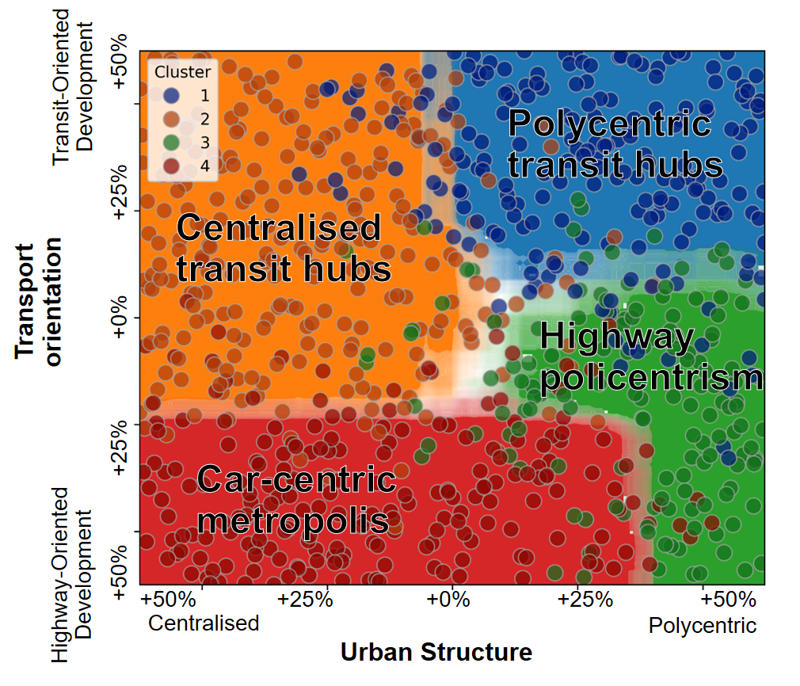

**Figure 2** Scenario map

# Conclusions

This paper introduces a “Scope, Simulation and Story” approach that integrates participatory processes, spatial development simulation models, spatial similarity analysis, and clustering techniques to define scenario boundaries that reflect spatial patterns. We apply this method to simulate spatial development in the Canton of Zurich for 2050 using a cellular automata Land Use Cover Change (LUCC) model. By varying LUCC transition rates and the influence of different LUCC drivers, we simulated an ensemble of 800 potential futures and identified four distinct scenarios.

This study shows how a “Scope, Simulation and Story” approach, instead of the classical “Story and Simulation” approach, has potential to enhance scenario planning. Our approach proposes a data-driven foundation that can help the construction of scenario narratives by ensuring that the generated scenarios are relevant for planning and spatially different.

# Acknowledgements

This research was conducted at the Future Cities Lab Global at ETH Zurich. Future Cities Lab Global is supported and funded by the National Research Foundation, Prime Minister’s Office, Singapore under its Campus for Research Excellence and Technological Enterprise (CREATE) programme and ETH Zurich (ETHZ), with additional contributions from the National University of Singapore (NUS), Nanyang Technological University (NTU), Singapore and the Singapore University of Technology and Design (SUTD).

# References

Abou Jaoude, G., Mumm, O. and Carlow, V.M. (2022) ‘An Overview of Scenario Approaches: A Guide for Urban Design and Planning’, *Journal of Planning Literature*, 37(3), pp. 467–487. Available at: https://doi.org/10.1177/08854122221083546.

Alcamo, J. (2008) ‘Chapter Six The SAS Approach: Combining Qualitative and Quantitative Knowledge in Environmental Scenarios’, in J. Alcamo (ed.) *Developments in Integrated Environmental Assessment*. Elsevier (Environmental Futures), pp. 123–150. Available at: https://doi.org/10.1016/S1574-101X(08)00406-7.

Avin, U. and Goodspeed, R. (2020) ‘Using Exploratory Scenarios in Planning Practice’, *Journal of the American Planning Association*, 86(4), pp. 403–416. Available at: https://doi.org/10.1080/01944363.2020.1746688.

Bankes, S. (1993) ‘Exploratory Modeling for Policy Analysis’, *Operations Research*, 41(3), pp. 435–449. Available at: https://doi.org/10.1287/opre.41.3.435.

Bryant, B.P. and Lempert, R.J. (2010) ‘Thinking inside the box: A participatory, computer-assisted approach to scenario discovery’, *Technological Forecasting and Social Change*, 77(1), pp. 34–49. Available at: https://doi.org/10.1016/j.techfore.2009.08.002.

Haga, C. *et al.* (2023) ‘Modeling desirable futures at local scale by combining the nature futures framework and multi-objective optimization’, *Sustainability Science* [Preprint]. Available at: https://doi.org/10.1007/s11625-023-01301-8.

Lempert, R.J., Popper, S.W. and Bankes, S.C. (2003) *Shaping the Next One Hundred Years: New Methods for Quantitative, Long-Term Policy Analysis*. RAND Corporation. Available at: https://www.rand.org/pubs/monograph_reports/MR1626.html (Accessed: 19 April 2023).

Nakicenovic, N. and Swart, R. (2000) *Special Report on Emissions Scenarios (SRES) – A Special Report of Working Group III of the Intergovernmental Panel on Climate Change*. Cambridge University Press.

Reed, P.M. *et al.* (2022) *Addressing uncertainty in multisector dynamics research*. Zenodo. Available at: https://doi.org/10.5281/zenodo.6110623.

# Biographies

Orlando Roman is a doctoral candidate at the Chair of Infrastructure Management at ETH Zurich. His research interest is in decision-making under deep uncertainty for infrastructure systems. This includes the modelling of urban systems, the generation of future scenarios and the identification of desirable adaptive pathways.

Jan Kwakkel is Full professor of Decision Making under Deep Uncertainty at TU Delft. His research interest is model-based support for decision making under deep uncertainty. His research focuses on the developing and testing innovative model-based techniques for the design of dynamic adaptive policy pathways.

Bryan Adey is Full professor at the Chair of Infrastructure Management at ETH Zurich. Prof. Adey’s research is focused on improving the effectiveness and efficiency of infrastructure management. This includes the definition and standardization of the infrastructure management process, from setting goals to determining optimal monitoring and intervention programs, and evaluating the performance of infrastructure management organisations.

Benjamin Black is a doctoral candidate at the Chair of Planning of Landscape and Urban Systems at ETH Zurich. His research interest are related to the simulation modelling of socio-ecological systems and quantification of uncertainty and non-stationarity in predictive models of land use change.

1. roman@ibi.baug.ethz.ch
2. j.h.kwakkel@tudelft.nl
3. adey@ibi.baug.ethz.ch
4. bblack@ethz.ch